

**THE CATHOLIC UNIVERSITY OF EASTERN AFRICA**

**PROJECT REPORT FOR FINAL YEAR STUDY IN BACHELOR OF SCIENCE IN COMPUTER SCIENCE**

**BY**

**OCHANYO PATRICK OGONYO**

**REG. NO: 1036658**

**POULTRY FARM MANAGEMENT SYSTEM (ECHOCHICK FARM)**

**MAY, 2024.**

Submitted in partial fulfilment of the requirements for the Degree of Bachelor of Science in Computer Science

# **DECLARATION**

This Research Project is my Original work and has not been submitted for a degree in any other university.

Signature: …………………………………. Date: ……………………………………….

**PATRICK OGONYO OCHANYO**

**REG: 1036658**

This project has been submitted for examination with my approval as university supervisor.

Signature: ………………………………... Date: ……………………………………….

**MR.** **CHRIS NANDASABA**

# **ACKNOWLEDGMENT**

I am profoundly grateful to the Almighty for the gift of life, knowledge, and strength that have empowered me to achieve this significant milestone. I extend my sincere appreciation to Mr. Nandasaba for his invaluable assistance, unwavering support, and insightful recommendations throughout the course of this project. His dedication to both academic pursuits and research has been inspiring.

# **DEDICATION**

I dedicate this project to the Almighty God, my eternal source of inspiration, unwavering support, knowledge, wisdom, and understanding. His guidance has been the cornerstone of my journey throughout this program, enabling me to soar on His wings.

I extend this dedication to my Supervisor, Mr. Chris Nandasaba, whose mentorship and guidance have been invaluable in shaping this work.

Additionally, I dedicate this project to my parents, Mrs. and Mr. Ochanyo and entire Ochanyo’ s family, whose unending encouragement propelled me to persevere and give my utmost to accomplish what I set out to achieve. Their unwavering support has been a constant source of strength.

To my beloved siblings, Benjamin Otieno, Agnes Akinyi, and Stephen Owino, whose lives have been touched in numerous ways by this pursuit. Your understanding and patience are deeply appreciated. My affection for all of you is immeasurable.

Thank you, and may God bless you abundantly.

# **ABSTRACT**

*The research proposal is based on a Poultry Farm Management System. Many poultry keepers still utilize the manual approach of keeping farm records. The results of this approach are it is time-consuming, unorganized, required data may easily be misplaced, and inefficient. Furthermore, required reports about different aspects of the farm cannot be easily retrieved in the time of need. This scenario makes it hard to monitor the state of birds in the poultry, expenses and income, and any other important information. To overcome these problems there is a need for an information system for proper management of the poultry farm. This system was proposed to provide a solution to the problem of poultry farm record keeping. In the current Poultry Farm Management Systems, the following problem was encountered physical farm records generation on sales, products and purchases, thus increasing company cost and slow in information conveyance, especially in the stock determination. Literature concerning poultry information management systems was evaluated. The proposal aimed to develop a poultry farm management system for Echo-Chick Farm. The objectives of the proposed system include developing a database application that can be used to maintain and give information about the livestock and financial information aspect of the poultry farm, providing a system that can facilitate the update of poultry farm records, automate the manual means of keeping poultry farm records, and develop a system that will aid in the presentation of reports pertaining the poultry farm. The legacy system utilized in the organization was also deliberated in more detail. With this, more needs for the Poultry Farm Management System were procured and the system was mapped out and carried out. The interfaces for the proposed system were implemented employing CSS, HTML and JavaScript for the front-end design. MYSQL was also used for database systems as a backend tool while PHP was applied to develop intercommunication. Upon finishing the implementation of the system, the new system will be then tested and validated. When developing the Poultry Farm Management System, the aim was to enable the system to generate the report on sales, production and purchase, to enable payment and to enter new details. This enables the whole process of information management in the poultry farm faster, more efficient and more convenient for the company. The Poultry Farm Information Management System automates the current poultry farm management Information system in the Echo-Chick Poultry Farm.*

Table of Contents

DECLARATION iii

ACKNOWLEDGMENT iv

DEDICATION v

ABSTRACT vi

List of Figures xi

List of Tables xii

Definition of Key Terms xiii

CHAPTER ONE INTRODUCTION 1

1.1 Motivation and Background 1

1.2 Background of research 2

1.3 Problem statement 3

1.4 Aim of research 3

1.5 Objectives of the research 3

1.6 Justification of research 3

1.7 Scope of research 4

1.8 Research organization 4

CHAPTER TWO REVIEW OF RELATED WORK 6

2.1 Chapter introduction 6

2.2 History of the research topic 6

2.2.1 Early Poultry Farming Practices 6

2.2.2 Industrialization and Technological Advancements 6

2.2.3 Emergence of Poultry Farm Management Systems 7

2.2.4 Key Milestones in Poultry Farm Management System Development 7

2.2.5 Driving Forces of Change 7

2.3 Review of Related prototypes and Systems (Global to Local) 8

2.3.1 Global Prototypes and Systems 8

2.3.2 Local Prototypes and Systems 9

2.4 Emerging Trends and Innovations in Poultry Farm Management 9

2.4.1 Precision Poultry Farming 9

2.4.2 Artificial Intelligence (AI) and Machine Learning (ML) Applications 9

2.4.3 Internet of Things (IoT) and Sensor Technologies 10

2.4.4 Predictive Analytics and Decision Support Systems 10

2.4.5 Robotics and Automation for Poultry Care and Management 10

2.4.6 Vertical Farming and Indoor Poultry Production 10

2.4.7 Blockchain Technology for Supply Chain Traceability 10

2.6 Chapter Summary 11

CHAPTER THREE: RESEARCH METHODOLOGY 12

3.1 Chapter Introduction 12

3.2 Methodology for Literature Review 12

3.3 Methodology for Requirement Specification, Data Collection, and Analysis Techniques 12

3.3.1 System Study: 13

3.3.2 Interviews: 13

3.3.3 Questionnaires: 13

3.3.4 Data Collection and Analysis: 13

3.4 Methodology for System Analysis (Current System) 13

3.4.1. Data Flow Diagrams (DFDs): 14

3.4.2. Context Diagrams: 14

3.4.3. Flowcharts: 14

3.5 Methodology for System Design (Proposed System) 14

3.5.1. Database Design: 14

3.5.2. DFDs (Data Flow Diagrams): 14

3.5.3. Context Diagrams: 15

3.5.4. Flowcharts: 15

3.5.5. Sequence Diagrams: 15

3.5.6. Collaboration Diagrams 15

3.5.7. Use Cases: 15

3.6 Methodology for System Implementation 15

3.6.1. Back-End Technologies: 16

3.6.2. Front-End Technologies 16

3.6.3. Database Technologies: 16

3.6.4. XAMPP Server: 16

3.7 Methodology for System Testing 17

3.8 Methodology for System Deployment 18

3.9 Chapter Summary 18

CHAPTER FOUR: SYSTEM ANALYSIS 19

4.1 Chapter introduction 19

4.2 Description of the Current Systems, Its Strengths and Weaknesses 19

4.2.1 Current System 19

4.2.2 Strengths of the Current System 19

4.2.3 Weaknesses of the Current System 19

4.3 Feasibility Study and Its Conclusion 20

4.3.1 Technical Feasibility: 20

4.3.2 Economic Feasibility: 20

4.3.3 Operational Feasibility: 21

4.3.4 Conclusion 21

4.4 Data I/O Analysis 21

4.5 Process Logic Design of the Current System 22

4.5.1. Data Collection: 22

4.5.2. Data Entry: 22

4.5.3. Data Analysis: 22

4.5.4. Decision-Making: 22

4.6 Chapter Summary 23

CHAPTER FIVE SYSTEM DESIGN OF THE PROPOSED SYSTEM 24

5.1 Introduction 24

5.2 Description of the Proposed System 24

5.2.1. Description 24

5.2.2. Strengths 24

5.2.3. Weaknesses 24

5.3 Requirements Analysis 25

5.3.1. Functional requirements 25

5.3.2. Non-Functional Requirements: 25

5.3.3. User Requirements 26

5.4 Conceptual Architecture of the Proposed System 28

5.5. Process Logic Design 29

5.5.1. Key Symbols Used in Process Modeling 29

5.5.2 Context Diagram 30

5.5.3. Level 1 Data Flow Diagram 31

5.5.4. Data Dictionary of Level 1 DFD of Echo-Chick Poultry Farm information management system 32

5.6 Database Design 34

5.6.1. Data Requirements 34

5.6.2. Identification of Entities and Associated Attributes 34

5.6.3 Modeling of Relationships between Entities. 36

5.6.4 The Entity Relationship Diagram (ERD 38

5.6.5. Data dictionary 38

5.8 Chapter Summary 41

CHAPTER SIX: IMPLEMENTATION SYSTEM & TESTING 42

6.1 Chapter Introduction 42

6.2 System screenshots 42

6.2.1. System login page 42

6.2.2. Authentication 42

6.2.3 User Registration 43

6.2.4 Employee Report 44

6.3 Testing plan 44

6.4 Evaluation plan 46

6.5 Chapter summary 46

CHAPTER SEVEN: CONCLUSIONS, FINDINGS & RECOMMENDATIONS 47

7.1 Introduction 47

7.2 Conclusion 47

7.3 Challenges Encountered 47

7.4 Future Recommendations 47

7.5 Conclusion 48

References 49

Appendix 51

Sample questionnaires 51

Sample interviews 51

Project Budget 52

Time Schedule 52

Sample code 53

# **List of Figures**

Figure 1 System Architecture 28

Figure 2 Symbol Used in Process Modeling 29

Figure 3 Sequence Diagram of the Poultry Farm Management Information System 30

Figure 4 Level 1 Data Flow Diagram of the Poultry Farm Management Information System 31

Figure 5 Relationship between the Employee and the purchase 36

Figure 6 Relationship between the product and the order 37

Figure 7 Relationship between the customer and the order 37

Figure 8 Relationship between the Order and Employee 37

Figure 9 Relationship between the Order and Employee 37

Figure 10 Entity Relationship Diagram (ERD) of Poultry Farm Management Information System 38

Figure 11 System Login 42

Figure 12 Authentication Response 43

Figure 13 User Registration Form 43

Figure 14 Employee report 44

Figure 15 Pie Chart Showing Responses of the Fifth Question of the Questionnaire 51

Figure 16 Project Budget 52

Figure 17 Time Schedule for the Project 52

Figure 18 Login.php 53

Figure 19 Admindashboard.php 53

# **List of Tables**

Table 1 Description of Process 32

Table 2 Description of Data Stores 33

Table 3 Description of External Entities 33

Table 4 Entities and the associated Attributes 34

Table 5 Category Table Structure 38

Table 6 Customer Table Structure 38

Table 7 Login Test Case 44

Table 8 User Registration Test Case 44

# **Definition of Key Terms**

**PFMS** Poultry Farm Management System

**PFIS** Poultry Farm Information System

**PPF** Precision poultry farming

# **CHAPTER ONE INTRODUCTION**

## **1.1 Motivation and Background**

Many people believe that one of the most difficult difficulties in the information society is that we are confronted with an ever-increasing volume of data. Data retrieval as a whole look to be less essential than the selection of meaningful bits of information: data is everywhere, but what it means and how we should act on it may be one of the century's largest challenges. If a civilization is an information society, it must have learnt to deal with the exponential growth of data. A poultry farm management system is a database software system for storing relevant or required information about a poultry farm. Because of the importance of effectively managing poultry farm activities, the system is essential.

Agriculture is the backbone of most countries around the world. According to Gonta Gobena & Urge (2021), poultry farming contributes considerably to food security, ecologically sound use of natural resources, provides accessible cash for emergency needs, and gives high-quality protein to the fast-growing human population, making it a major source of livelihood for most rural areas. Because the cost of producing sheep, cattle, and goat meat continues to rise, customer preferences have switched to poultry meat (white meat), which has social, ecological, economic, and health advantages over other types of red meat (Mao et al., 2016). All of Kenya's livestock agriculture is heavily capitalized (commercialized), with poultry being the most so. Guinea fowls, pigeons, turkeys, ducks, and chickens are among the most popular poultry raised in Kenya. Chicken, turkeys, and guinea fowls are the most economically and commercially important poultry species, with chicken dominating.

Poultry production was not considered a necessary occupation in the past. There are three types of poultry management systems: semi-intensive, extensive, and intense. They are distinguished by their flock capacity and input-output relationship. As a result of scientific advancements in disease control, artificial incubation, and nutritional requirements, a large flock size is maintained. Poultry birds reach maturity quicker than other livestock breeds, and they produce economic returns in as little as 3-4 months (Kebede, 2017). Poultry meat and eggs serve a vital part in bridging the protein gap in Kenya, and they are widely appreciated. To assist them to manage their everyday operations, modern poultry farming firms require a complete management system. The system should include personnel office administration, purchase–sales–inventory management, environmental monitoring and control in poultry houses, and individual poultry information monitoring (Zheng et al., 2021). It must also incorporate product traceability management, diagnostics, and early warning of poultry diseases to meet future development demands.

Making sound farm management decisions necessitates a thorough set of records. This research proposal discusses the importance of farm records, depreciation, enterprise accounting, assets inventory, cash flow, and profit and loss, as well as other major record-keeping components and concepts such as depreciation, enterprise accounting, assets inventory, cash flow, and profit and loss. Computer-based record systems are widely available and should be considered when setting up a record system. In recent years, software's ability to support farm records has skyrocketed (Saiz-Rubio & Rovira-Más, 2020). Different software programs differ in terms of complexity and expense. However, the information needed for farm business planning and management may be found in the output cash flow, balance sheet, income statements, and enterprise accounts. These papers may be created using computers.

## **1.2 Background of research**

The need for, benefits and uses of information for farm decision making has engaged the attention of researchers, farmers and policymakers over the years. Information can be defined as the data that has been transformed into a form that is useful and meaningful for decision-making with data distinguished as raw facts, objects, figures etc. The 'system' about information relates to the integration and interconnection of components of the collection, storage, distribution, and processing of information to support decision-making. By extension of this non-farm definition, farm information system (FIS), then, can be appreciated as a tool to help farms in forwarding planning, risk management, and by the use of information. Poultry production enterprises need good information systems to ensure success.

## **1.3 Problem statement**

Most poultry farmers still utilize the manual approach of keeping farm records. The results of this approach are time-consuming, unorganized, required data may easily be misplaced, and inefficient. Furthermore, required reports on different aspects of the farm cannot be easily retrieved in the time of need. Hence, make it hard to monitor the state of birds on the farm, expenses and income, and any other important information. In addition, the manual system is also characterized by lack of information sharing in real-time, slow information conveyed especially in the determination of stocks levels after transaction processes, consumption of a lot of time, thus increasing the company cost, and lack of effective data recovery in case of any disaster such as fire outbreaks, damages, flood among other disasters. To get a solution to these problems there is need for an information system for proper management of the poultry farm.

## **1.4 Aim of research**

The aim of this research is to develop a comprehensive Poultry Farm Management System (PFMS) to streamline operations, automate processes, and improve the efficiency and productivity of poultry farming.

## **1.5 Objectives of the research**

The following are the objectives of the research:

1. To establish a decentralized data model tailored for an efficient Poultry Farm Management System.
2. To facilitate remote customer orders from various locations.
3. To design and implement a system capable of generating comprehensive records encompassing all stored details.

## **1.6 Justification of research**

According to Mady et al. (2020), the poultry production business necessitates a robust management system to ensure successful operations. Building upon their findings, this research study holds significance as it aims to offer a solution by automating the record-keeping processes in poultry farms. This initiative is geared towards enhancing data management efficiency and facilitating the generation of comprehensive reports. Furthermore, the study aspires to contribute valuable insights that can serve as a fundamental reference for researchers exploring similar fields. Considering the identified challenges, the implementation of the Echo-chick system emerges as an essential solution, ensuring streamlined and effective management practices within poultry farming.

## **1.7 Scope of research**

The scope of this research work encompasses the Design and Implementation of the Echo Chick poultry farm management system, specifically tailored for the EchoChick poultry farm. The inefficiencies observed in the previous manual system, such as time-consuming processes, disorganization, and the risk of data misplacement, prompted the necessity for a more efficient solution. The system's primary focus revolves around recording vital information related to rearing birds and managing financial aspects, including expenses and income. To address these challenges, the proposed system will implement the following key features:

1. Automation of Operations: The system will streamline and automate various poultry farm management tasks to enhance efficiency.
2. Web-Based System: Enabling a web-based platform will empower customers to place orders conveniently from any location, improving accessibility and customer engagement.

The scope is deliberately limited to these specific features and targeted aspects of poultry farm management to ensure a focused and effective resolution of the identified challenges faced by the Echo Chick poultry farm.

## **1.8 Research organization**

The research proposal is organized into seven chapters as follows:

The first chapter provides an introductory overview of the research, encompassing the motivation, background, problem statement, research aim, objectives, justification, scope, and an outline of the research organization. Chapter two Literature Review, delves into a comprehensive review of the existing literature, exploring related systems, management theories, and methodological structures associated with the proposed system. Chapter 3: Research Methodology, this chapter offers an in-depth exploration of the research methodology, focusing on the methods utilized for data collection.

Chapter 4 System Analysis, primarily deals with the analysis of the proposed system, conducting requirement analysis, feasibility studies, and utilizing tools such as use case diagrams, flowcharts, and activity diagrams. In Chapter five System Design, the focus is on the design phase, reviewing the strengths and weaknesses of the proposed system. This section further elucidates the conceptual architecture and database design of the system. Chapter six System Implementation and Testing is dedicated to the implementation of the system, providing detailed insights into the actual development process, accompanied by screenshots and illustrations derived from the developed system.

Chapter seven: Conclusion, Findings, and Recommendations. The final chapter, Chapter 7, encapsulates the conclusions drawn from the research, outlines the key findings, discusses encountered challenges, and offers recommendations for future endeavors in the field.

# **CHAPTER TWO REVIEW OF RELATED WORK**

## **2.1 Chapter introduction**

This chapter includes facts and ideas from other scholars whose work is important to the setting of this study. It examines many sources from which the researcher drew constructive ideas that were deemed necessary for the study's completion. Our Poultry Farm Management System is a full-featured software with an easy-to-use user interface that allows you to graphically manage your poultry. The aim of the research proposal is to develop a Poultry farm management system. That would meet the following objectives; to automate the manual means of taking poultry farm records, to enable customers to register and validate their logins, they can take orders from anywhere and to develop a system that should be able to provide views for all stored details.

## **2.2 History of the research topic**

The management of poultry farms has undergone a significant transformation over the centuries, evolving from rudimentary practices to sophisticated systems that incorporate advanced technologies and data analytics. This chapter explores the historical trajectory of poultry farm management systems, highlighting key milestones, innovations, and driving forces that have shaped the industry.

### **2.2.1 Early Poultry Farming Practices**

The domestication of chickens, dating back to around 10,000 years ago, marked the beginning of poultry farming. Early poultry farming practices were characterized by small-scale, subsistence-level operations, with chickens raised primarily for their eggs and meat (Emal & Muhsni, 2017). These traditional methods involved manual labor for feeding, cleaning, and record-keeping, and relied heavily on local knowledge and experience.

### **2.2.2 Industrialization and Technological Advancements**

The industrialization of agriculture in the late 19th and early 20th centuries brought about a revolution in poultry farming. Intensive rearing systems, characterized by large-scale confinement houses, mechanized feeding and cleaning, and selective breeding programs, led to significant increases in poultry production (Lukefahr et al., 2004). Technological advancements, such as artificial incubators and feed formulations, further enhanced efficiency and productivity.

### **2.2.3 Emergence of Poultry Farm Management Systems**

The growing complexity of large-scale poultry farming operations necessitated the development of more organized and systematic management approaches. In the mid-20th century, poultry farm management systems began to emerge, initially as manual record-keeping tools, but gradually evolving into computerized systems capable of storing, analyzing, and presenting vast amounts of data (Gordon, (Ed.). 2017).

### **2.2.4 Key Milestones in Poultry Farm Management System Development**

The development of poultry farm management systems has been marked by several significant milestones:

1. 1950s: Introduction of punch card systems for recording poultry production data.
2. 1960s: Development of early mainframe-based poultry farm management software.
3. 1970s: Adoption of microcomputers for poultry farm management applications
4. 1980s: Emergence of integrated poultry farm management systems
5. 1990s: Widespread adoption of personal computers and networking technologies
6. 2000s: Development of web-based and cloud-based poultry farm management systems

### **2.2.5 Driving Forces of Change**

Several factors have driven the evolution of poultry farm management systems:

1. Rising demand for poultry products: Increasing global demand for poultry products has incentivized producers to adopt more efficient and effective management practices.
2. Technological advancements: The continuous development of new technologies, such as sensors, automation, and data analytics, has revolutionized poultry farm management.
3. Scientific research: Advances in poultry science, nutrition, and disease control have provided valuable insights for improving poultry farm management practices.
4. Environmental concerns: The need to balance productivity with environmental sustainability has driven the development of eco-friendly poultry farm management practices.

Poultry farm management systems have undergone a remarkable transformation, evolving from simple record-keeping tools to sophisticated systems that integrate advanced technologies and data analytics. These advancements have played a crucial role in enhancing poultry production efficiency, optimizing resource utilization, and ensuring the health and welfare of poultry flocks. As the industry continues to face new challenges and opportunities, poultry farm management systems will undoubtedly play an even more critical role in ensuring the sustainable and profitable production of poultry products.

## **2.3 Review of Related prototypes and Systems (Global to Local)**

The landscape of poultry farm management systems is characterized by a diverse range of prototypes and systems, ranging from simple, cloud-based applications to comprehensive enterprise resource planning (ERP) software solutions (Debauche et al., 2021). This section provides a comprehensive review and analysis of existing prototypes and systems, encompassing both global and local offerings.

### **2.3.1 Global Prototypes and Systems**

Several global poultry farm management systems have gained recognition for their comprehensive functionalities and user-friendly interfaces:

1. PoultryCare ERP: This robust ERP system encompasses a wide range of modules, including flock management, feed management, financial management, and reporting (Ng'ang'a, 2014). It is particularly well-suited for large-scale commercial poultry operations.
2. LivestockManager: This cloud-based software offers a user-friendly interface and a comprehensive suite of features for managing poultry flocks, including feed tracking, health monitoring, and data analytics.
3. FarmLogs: This comprehensive farm management platform provides a range of modules for managing poultry production, including inventory management, task management, and real-time data visualization (Singh, Khilari & Nair, 2022).
4. ePoultry: This software is specifically designed for managing egg production, providing features for egg tracking, grading, and sales management (Chai et al., 2023).
5. AgData: This cloud-based platform offers a comprehensive suite of tools for managing agricultural operations, including poultry farming. It is particularly well-suited for integrated farming enterprises.

### **2.3.2 Local Prototypes and Systems**

In addition to globally recognized systems, several local prototypes and systems have emerged, tailored to the specific needs and contexts of poultry farmers in various regions:

1. PoultryHub (Kenya): This mobile application developed in Kenya provides poultry farmers with access to localized information on feed rations, health management, and market prices.
2. AgroCenta (Ghana): This platform connects smallholder poultry farmers in Ghana with buyers and suppliers, facilitating access to inputs and markets.
3. iCow (India): This cloud-based platform provides comprehensive livestock management tools, including modules for poultry farming, specifically designed for the Indian market.
4. SmartBroiler (Indonesia): This mobile application developed in Indonesia helps broiler farmers optimize feed utilization and improve broiler performance.
5. AgroGuardian (Bangladesh): This platform provides poultry farmers in Bangladesh with real-time monitoring of environmental conditions in their poultry houses.

## **2.4 Emerging Trends and Innovations in Poultry Farm Management**

The poultry industry is constantly evolving, driven by the need to increase productivity, improve efficiency, and ensure the health and welfare of poultry flocks. This evolution is being fueled by a wave of emerging trends and innovations in poultry farm management systems.

### **2.4.1 Precision Poultry Farming**

Precision poultry farming (PPF) is a data-driven approach to poultry management that utilizes advanced technologies to optimize production and resource utilization (Jobe, 2020). PPF employs sensors, data analytics, and automation to monitor and control various aspects of poultry production, including environmental conditions, feed consumption, and individual bird performance.

### **2.4.2 Artificial Intelligence (AI) and Machine Learning (ML) Applications**

AI and ML are transforming poultry farm management by providing new insights into flock health, behavior, and production patterns (Ojo et al., 2022). These technologies are being used to develop predictive models for disease outbreaks, detect abnormalities in bird behavior, and optimize feed rations.

### **2.4.3 Internet of Things (IoT) and Sensor Technologies**

IoT and sensor technologies are enabling real-time monitoring of environmental parameters, such as temperature, humidity, and ammonia levels, in poultry houses (Astill et al., 2020). This data can be used to automate environmental control systems and proactively identify potential issues that could affect bird health and performance.

### **2.4.4 Predictive Analytics and Decision Support Systems**

Predictive analytics and decision support systems are helping poultry farmers make more informed decisions by providing insights into future trends and potential risks. These systems can predict bird growth rates, identify potential disease outbreaks, and suggest optimal feed rations based on real-time data.

### **2.4.5 Robotics and Automation for Poultry Care and Management**

Robotics and automation are being introduced to automate repetitive tasks in poultry care and management, such as feeding, cleaning, and egg collection (Ren et al., 2020). This can reduce labor costs, improve efficiency, and enhance worker safety.

### **2.4.6 Vertical Farming and Indoor Poultry Production**

Vertical farming and indoor poultry production systems are gaining traction as they offer opportunities to reduce the environmental impact of poultry production and improve biosecurity. These systems can be located in urban areas, closer to consumers, reducing transportation costs and emissions.

### **2.4.7 Blockchain Technology for Supply Chain Traceability**

Blockchain technology is being explored for its potential to enhance traceability and transparency in the poultry supply chain. Blockchain can provide a secure and tamper-proof record of bird movement, feed ingredients, and processing history, ensuring consumer confidence in the safety and quality of poultry products (Alles, & Gray, 2020).

The emerging trends and innovations in poultry farm management are shaping the future of the industry, driving towards more sustainable, efficient, and data-driven production practices. As these technologies continue to evolve, poultry farmers will be equipped with powerful tools to optimize their operations, ensure the health and welfare of their flocks, and meet the growing demand for high-quality poultry products.  
**2.5 Research gap to be filled by your research**  
The proposed Poultry Farm Management System (PFMS) aims to address several critical aspects of poultry farming, including data management, customer service, and record-keeping. However, there are still some research gaps that need to be addressed to fully optimize the system's effectiveness and impact.

**Data Security and Privacy**: Decentralized data models offer enhanced resilience against data loss or corruption, but they also introduce new security and privacy challenges. Research is needed to develop robust encryption techniques, access control mechanisms, and data governance policies to protect sensitive poultry farm data from unauthorized access and breaches.

**Data Integration and Interoperability**: The PFMS should seamlessly integrate data from various sources, such as sensors, IoT devices, external databases, and customer relationship management systems. Research is needed to develop standardized data formats, middleware solutions, and data harmonization techniques to facilitate seamless data exchange and integration.

## **2.6 Chapter Summary**

This chapter has provided a comprehensive overview of the historical development and current trends in poultry farm management systems. It began by tracing the evolution of poultry farming from early domestication practices to the sophisticated, technology-driven approaches seen today. It then examined various global and local prototypes and systems currently in use, ranging from robust ERP systems to mobile and cloud-based solutions tailored to specific regional needs. We also discussed emerging trends and innovations like precision poultry farming, AI and ML applications, IoT and sensor technologies, and blockchain for supply chain traceability, emphasizing their impact on the industry's efficiency and sustainability. The chapter concluded by identifying specific research gaps that the proposed Poultry Farm Management System aims to fill, such as data security, privacy, and system interoperability. This discussion sets the stage for the development of a system that not only automates traditional record-keeping but also integrates cutting-edge technologies to enhance operational efficiency and decision-making at Echo-Chick Farm.

# **CHAPTER THREE: RESEARCH METHODOLOGY**

## **3.1 Chapter Introduction**

This chapter outlines the research methodology that will be employed to develop the proposed Poultry Farm Management System (PFMS). The methodology covers the entire research spectrum, from literature review and requirement specification to system design, implementation, testing, and deployment.

## **3.2 Methodology for Literature Review**

The methodology for the literature review entails a thorough exploration of existing poultry farm management systems, focusing on their functionalities, limitations, and technological advancements relevant to poultry farming. The process will involve a comprehensive search across various scholarly databases, industry-specific publications, and pertinent websites.

The initial step will include identifying and accessing academic databases that feature research articles, conference papers, and scholarly journals related to poultry farm management systems. This will facilitate the gathering of scholarly perspectives, studies, and empirical research findings concerning the subject matter.

We will also scrutinize industry-specific publications such as reports, white papers, and publications from reputable organizations and associations in the agriculture and poultry farming sectors. These resources will provide insights into practical implementations, case studies, and industry trends regarding poultry farm management.

We will explore relevant websites, forums, and online platforms dedicated to poultry farming technology to capture the latest advancements, innovative tools, and emerging trends in the field. This comprehensive approach aims to gather a diverse range of scholarly and practical sources to enrich the understanding of existing systems and advancements in poultry farm management technology.

## **3.3 Methodology for Requirement Specification, Data Collection, and Analysis Techniques**

The methodology for requirement specification, data collection, and analysis in developing the PFMS involves a comprehensive approach to understanding the current system and gathering insights to shape the proposed solution.

### **3.3.1 System Study:**

We conducted a detailed system study using interviews, questionnaires, and observations to gather comprehensive data about the current poultry farm management systems. This step helped identify the strengths and weaknesses of existing practices and established the baseline for the proposed system’s functionality.

### **3.3.2 Interviews:**

In-depth interviews with poultry farmers, farm managers, and industry experts helped gather qualitative insights into the operational challenges and expectations for the new system, enhancing the stakeholder-driven design of the PFMS.

### **3.3.3 Questionnaires:**

Supplementing the interviews, a structured questionnaire was developed and distributed among system users. This method enabled the collection of data from a wider pool of stakeholders, overcoming geographical barriers. The information gathered through these questionnaires was utilized to refine the understanding of the current system and further delineate the requirements for the proposed PFMS.

### **3.3.4 Data Collection and Analysis:**

The data collected encompassed various aspects of farm operations, such as flock size, feed consumption, egg production, and financial records. This data was subjected to statistical analysis and data visualization techniques to identify patterns, trends, and areas requiring improvement. By employing statistical tools and visualization methods, the aim was to derive actionable insights and make informed decisions in designing the proposed PFMS.

## **3.4 Methodology for System Analysis (Current System)**

The system analysis process involves an in-depth examination of the data collected during the system study to pinpoint essential system requirements. The data analysis primarily utilized Microsoft Excel, facilitating the generation of statistical figures, such as pie charts, to visually represent the comprehensive analysis findings derived from the collected data.

Furthermore, the methodology for system analysis (specifically for the current system) encompasses several techniques:

### **3.4.1. Data Flow Diagrams (DFDs):**

These diagrams will be employed to visually showcase the movement of data within the existing system. By mapping data sources, data stores, and various data processing activities, DFDs offer a clear depiction of how information flows through the system.

### **3.4.2. Context Diagrams:**

This technique will outline the scope and boundaries of the current system, delineating its interactions with external entities. Context diagrams provide a high-level overview, showcasing the system's relationship with its external environment.

### **3.4.3. Flowcharts:**

Utilized to illustrate the sequential steps involved in critical tasks within the present system. Flowcharts offer a detailed breakdown of processes, enabling a clearer understanding of the system's operations through a step-by-step visual representation.

These analysis techniques DFDs, context diagrams, and flowcharts will collectively provide a comprehensive understanding of the current system's functioning, data flow, boundaries, and essential processes. This thorough evaluation will serve as a foundational step toward identifying areas for improvement and facilitating the design of an enhanced Poultry Farm Management System.

## **3.5 Methodology for System Design (Proposed System)**

The proposed system will be designed using the following techniques:

### **3.5.1. Database Design:**

This technique involves structuring the database for the system. It includes defining tables (entities), their respective attributes (fields), establishing relationships between tables, and ensuring data integrity through constraints like primary keys, foreign keys, and normalization.

### **3.5.2. DFDs (Data Flow Diagrams):**

DFDs are graphical representations that illustrate the flow of data within the system. They show how data moves from input to processing to output. These diagrams help in understanding the data movement and processing steps in the system.

### **3.5.3. Context Diagrams:**

Context diagrams provide a high-level view of the system by showcasing its interactions with external entities or systems. They define the system's boundaries and the external entities it interacts with, offering an overview of its functionalities.

### **3.5.4. Flowcharts:**

Flowcharts represent the step-by-step logic of processes within the system. They provide a visual representation of the sequence of actions or decisions within specific tasks, enabling a clear understanding of the system's operational flow.

### **3.5.5. Sequence Diagrams:**

These diagrams illustrate interactions between various system components or objects during specific use cases or scenarios. They show the sequence of messages passed between objects, detailing the interactions and their chronological order.

**3.5.6. Collaboration Diagrams:**

Collaboration diagrams focus on how objects collaborate to achieve a specific functionality within the system. They depict the relationships between objects and the messages exchanged between them, emphasizing collaboration for system functionality.

### **3.5.7. Use Cases:**

Use cases outline various interactions between system users and the system itself. They detail different scenarios, user actions, system responses, and alternative flows, providing a comprehensive understanding of system-user interactions.

Each of these methodologies plays a crucial role in different aspects of system design, contributing to a comprehensive and efficient development process for the proposed Poultry Farm Management System.

## **3.6 Methodology for System Implementation**

The implementation phase covers the development of system modules and integration of the system. Tools including XAMMP sever, PHP, Bootstrap, HTML and MySQL were used

The following tools were used to implement the system;

### **3.6.1. Back-End Technologies:**

#### **3.6.1.2 PHP**

A server-side scripting language used for developing dynamic web applications. In the context of implementing the Poultry Farm Management System, PHP will handle the server-side logic, processing user requests, and interacting with the database. It's commonly used for its ability to generate dynamic content, connect to databases, and perform server-side operations efficiently.

**3.6.2. Front-End Technologies:**

#### **3.6.2.1 HTML (Hypertext Markup Language):**

HTML is the standard markup language used to create the structure and content of web pages. It defines the elements and layout of web documents.

#### **3.6.2.1 CSS (Cascading Style Sheets):**

CSS is used for styling and presentation of HTML elements, defining the visual layout, colors, fonts, and overall design of web pages.

#### **3.6.2.3 JavaScript:**

JavaScript is a scripting language that enables interactive elements and dynamic behavior on web pages. It is used to create responsive and user-friendly interfaces, handle client-side operations, and enhance the user experience.

### **3.6.3. Database Technologies:**

MySQL is a widely used open-source relational database management system (RDBMS). It facilitates data storage, retrieval, and management (ElDahshan et al., 2022). In the context of the proposed Poultry Farm Management System, MySQL will be employed as the database technology to store and manage various types of farm-related data, ensuring data integrity, security, and scalability.

### **3.6.4. XAMPP Server:**

XAMPP stands for Cross-Platform (X), Apache (A), MariaDB (formerly MySQL) (M), PHP (P), and Perl (P). It's a software package that bundles essential components required for web development:

#### **3.6.4.1 Apache Server:**

Apache is a widely-used open-source web server software that processes requests and delivers web content to users' browsers. In the context of XAMPP, Apache serves as the primary web server, handling HTTP requests for web pages and other web-related files.

#### **3.6.4.2 MariaDB (MySQL):**

MariaDB is an open-source relational database management system (RDBMS) and is a fork of MySQL. It is used to store and manage the system's data efficiently. XAMPP includes MariaDB as its database component.

#### **3.6.4.3 PHP:**

PHP (Hypertext Preprocessor) is a server-side scripting language used for creating dynamic web pages. It's embedded within web pages and executed on the server. PHP processes data, interacts with databases, and generates dynamic content for web applications.

#### **3.6.4.4. Perl:**

Perl is a high-level programming language used for various tasks such as text processing, web development, and system administration. While PHP is more commonly used in web applications, Perl can serve as an additional scripting language in certain scenarios.

These technologies collectively form the backbone of the Poultry Farm Management System, with PHP handling the server-side operations, HTML, CSS, and JavaScript providing the user interface and interactivity, and MySQL managing the storage and retrieval of data required for the system's functionalities. This technology stack is chosen for its compatibility, efficiency, and suitability for web-based application development.

## **3.7 Methodology for System Testing**

At the end of the implementation phase, the system was tested to ensure it attains the stated objectives. We focused on the systematic discovery and debugging of defects. The following procedures were used to test the system:

i. Unit testing where each component of the system was independently be tested

ii. Integration testing where all system components were tested as a whole

iii. And finally, user acceptance testing for the system to be tested by a small number of end-users of the system.

iv. Once these phases are completed, the system was ready for installation, migration, support and maintenance

## **3.8 Methodology for System Deployment**

The proposed system will be deployed following a phased approach:

1. Development Phase: The system will be developed and tested in a controlled environment.
2. Testing Phase: The system will undergo rigorous testing to ensure its stability and performance.
3. Pilot Deployment: The system will be deployed in a pilot phase involving a small group of users to gather feedback and identify any potential issues.
4. Full Deployment: The system will be rolled out to all users after successful pilot testing and refinement.

## **3.9 Chapter Summary**

This chapter has outlined the comprehensive research methodology that will guide the development of the proposed Poultry Farm Management System (PFMS). The methodology encompasses a thorough literature review, rigorous requirement specification, detailed system analysis and design, systematic implementation, and comprehensive testing. The phased deployment approach will ensure a smooth and successful transition from the current system to the proposed PFMS. The research methodology aims to address all aspects of PFMS development, ensuring the creation of a robust, efficient, and user-friendly system that will significantly enhance poultry farm management practices.

# **CHAPTER FOUR: SYSTEM ANALYSIS**

## **4.1 Chapter introduction**

This chapter delves into a thorough analysis of the existing poultry farm management system, identifying its strengths, weaknesses, and limitations. By understanding the current system's capabilities and shortcomings, we can lay the groundwork for designing a more efficient and effective system that addresses the identified gaps.

## **4.2 Description of the Current Systems, Its Strengths and Weaknesses**

### **4.2.1 Current System**

The existing poultry farm management system, predominantly reliant on manual processes despite some degree of computerization, serves as the primary method adopted by numerous poultry farms throughout the country. However, despite its historical reliance and partial integration of computerized elements, this system exhibits inherent strengths and weaknesses that significantly impact its efficacy and operational efficiency.

### **4.2.2 Strengths of the Current System**

1. Dependability: Over time, the manual system has established itself as a reliable method due to its familiarity and entrenched use within the poultry farming community.
2. Ease of Familiarity: Familiarity among the workforce: The manual approach often entails practices that the workforce is accustomed to, ensuring a relatively smooth operation due to familiarity.
3. Low initial cost: The manual system does not require significant upfront investments in software or hardware.

### **4.2.3 Weaknesses of the Current System**

1. Heavy Reliance on Paper Records and Spreadsheets: The predominant reliance on paper-based records and spreadsheets poses a significant limitation. Such reliance is susceptible to human errors, including data entry mistakes, misplacement, and loss of crucial information.
2. Limited Accessibility and Real-Time Information: The manual system's lack of integration with digital platforms restricts accessibility and real-time access to critical farm data. This limitation impedes the timely retrieval and utilization of essential information necessary for decision-making processes.
3. Inefficiencies in Data Processing: Manual record-keeping methods often result in slower data processing and analysis. This inefficiency hampers the ability to swiftly generate accurate reports or glean meaningful insights from the collected data.
4. Reduced Scalability and Expandability: As the poultry farm expands or operations become more complex, the manual system struggles to scale or accommodate increased complexities effectively. This limitation impedes growth and adaptability to changing business needs.
5. Vulnerability to Errors and Data Loss: The manual nature of the system renders it susceptible to errors, inaccuracies, and potential data loss. Incidences such as misfiling or accidental data deletion may compromise the integrity of farm records.
6. Limited Security Measures: Paper-based records lack robust security measures, making them susceptible to unauthorized access, tampering, or loss due to physical damage, theft, or disasters.

## **4.3 Feasibility Study and Its Conclusion**

A comprehensive feasibility study was meticulously conducted to evaluate the practicality and viability of initiating the development of a new poultry farm management system. The study meticulously assessed various critical factors imperative for the successful implementation and sustainability of the proposed system.

### **4.3.1 Technical Feasibility:**

An in-depth analysis of the technical requirements and resources essential for the implementation of the new poultry farm management system was conducted. It was ascertained that the requisite technology and infrastructure needed for the system's development and deployment are readily available and fall within the farm's existing technical capabilities. The system can be effectively integrated into the farm's existing technological framework without requiring substantial overhauls or investments in new infrastructure.

### **4.3.2 Economic Feasibility:**

An exhaustive assessment of the project's economic feasibility was undertaken, considering the costs associated with the system's development, implementation, and ongoing maintenance against the anticipated benefits and returns. The economic analysis revealed that the expected benefits derived from the new system significantly outweigh the incurred costs. While initial investment and implementation costs are projected, the long-term advantages such as increased operational efficiency, reduced manual labor, improved data accuracy, and enhanced decision-making capabilities justify the investment.

### **4.3.3 Operational Feasibility:**

An evaluation of the operational aspects of implementing the new system was conducted, focusing on the farm staff's readiness, willingness, and capacity to adapt to the technological changes. It was determined that the farm personnel exhibit a positive inclination towards adopting the new system. Adequate training programs and support mechanisms can be implemented to ensure a seamless transition. The staff's enthusiasm and commitment to embracing the new technology signify a favorable operational feasibility.

### **4.3.4 Conclusion**

The comprehensive feasibility study conducted on technical, economic, and operational fronts concludes that initiating the development of a new poultry farm management system is both viable and prudent. The results indicate that the proposed system aligns well with the farm's technical capabilities, offers substantial economic benefits that outweigh the costs, and possesses operational feasibility through staff readiness and willingness to adapt. Therefore, based on the conclusive findings of the feasibility study, it is recommended and concluded that proceeding with the development of the new poultry farm management system is a feasible and worthwhile endeavor that promises significant benefits and enhancements to the farm's operational efficiency and management capabilities.

## **4.4 Data I/O Analysis**

The current system captures data on various aspects of poultry farm operations, including:

1. Bird inventory: Flock size, age, breed, and health status.
2. Feed consumption: Feed types, quantities, and consumption patterns.
3. Egg production: Daily egg production, egg quality, and grading.
4. Financial transactions: Expenses, revenue, and profit margins.

This data is stored in paper-based records and spreadsheets, making it difficult to analyze and extract meaningful insights.

## **4.5 Process Logic Design of the Current System**

The operational methodology within the present poultry farm management system adheres to a sequential manual process flow comprising several sequential steps:

### **4.5.1. Data Collection:**

1. Manual Record-Keeping: Farmworkers engage in the manual collection of pertinent data related to diverse aspects of poultry farm operations. This encompasses meticulous recording of bird inventory, encompassing flock size, breed specifics, age distribution, and meticulous health status documentation.
2. Feed Consumption Monitoring: Regular and diligent recording of feed-related data, including feed types, allocated quantities, and consumption patterns across different poultry flocks or breeds.
3. Egg Production Documentation: Methodical documentation of daily egg production figures, encompassing quantitative metrics, quality assessments, and grading standards.

### **4.5.2. Data Entry:**

Manual Input Processes: The meticulously recorded data is transcribed into the system's primary repositories, predominantly paper-based records or spreadsheets. This step involves labor-intensive manual entry processes to transfer data from physical records to digital or analog repositories.

### **4.5.3. Data Analysis:**

Limited Analytical Scope: The scope of data analysis remains confined to rudimentary calculations and basic aggregations, typically encompassing summaries such as total feed consumption or cumulative egg production. The system's inherent limitations restrict sophisticated data analytics, predictive modeling, or advanced statistical inferences.

### **4.5.4. Decision-Making:**

Reliance on Experience and Intuition: Farm managers heavily rely on their experiential knowledge and intuition to derive insights and make critical decisions. Given the limited analytical capabilities of the system, decisions are often made based on past experiences rather than data-driven insights.

The prevailing process logic design within the current poultry farm management system inherently relies on manual operations at every stage of the data lifecycle. Although these manual methodologies have facilitated the fundamental recording and storage of essential farm operation data, they concurrently introduce significant inefficiencies and limitations.

## **4.6 Chapter Summary**

This chapter has provided a comprehensive analysis of the current poultry farm management system, highlighting its strengths and weaknesses. The feasibility study concluded that developing a new system is a viable and beneficial undertaking. The data I/O analysis revealed the limitations of the manual system, and the process logic design illustrated the inefficiencies of the current data management process. Understanding these limitations will be crucial in designing a new system that addresses the identified gaps and enhances the overall efficiency and productivity of the poultry farm.

# **CHAPTER FIVE SYSTEM DESIGN OF THE PROPOSED SYSTEM**

## **5.1 Introduction**

This chapter outlines the system design of the proposed Poultry Farm Management System (PFMS). The system design encompasses the conceptual architecture, process logic, database design, and input/output (I/O) design.

## **5.2 Description of the Proposed System**

### **5.2.1. Description**

The proposed PFMS is a comprehensive web-based application designed to streamline operations, automate processes, and improve the efficiency and productivity of poultry farming. The system will provide poultry farmers with a centralized platform for managing their stock, feed, and financial data.

### **5.2.2. Strengths**

1. Streamlined Operations: The system will automate many manual tasks, such as recording feed consumption, tracking bird health, and generating reports, freeing up time for farmers to focus on more critical tasks.
2. Improved Efficiency: The system will provide farmers with real-time data on their flock, feed, and finances, enabling them to make informed decisions to optimize their operations.
3. Enhanced Productivity: The system will help farmers to identify and address problems early on, leading to healthier flocks and increased egg production.
4. Reduced Costs: The system will help farmers to identify and eliminate waste, leading to reduced feed costs and other expenses.
5. Improved Customer Service: The system will allow farmers to track orders and communicate with customers more effectively, leading to improved customer satisfaction.

### **5.2.3. Weaknesses**

1. Initial Costs: The cost of implementing the PFMS may be prohibitive for some farms.
2. Training Requirements: Farmers may require training to use the system effectively.
3. Technical Dependence: The system is reliant on technology, and any disruptions in service could impact farm operations.
4. Data Security: The system will store sensitive data, so it is important to implement robust security measures to protect this information.
5. Limited Scalability: The system may not be able to scale to meet the needs of very large farms.

## **5.3 Requirements Analysis**

Based on the outcomes from the system study the users, functional and non-functional requirements of the Poultry farm information management system were evaluated as follows:

### **5.3.1. Functional requirements**

The functional requirements are activities that the system must be able to perform. The system Provides he following functionalities:

1. User Details Management: Capabilities to create, retrieve, update, and delete user information.
2. Product and Details Views: Ability to view all stored user and product details.
3. Product Registration: Facilities for registering new product details.
4. Simple user interface: An interface that is easy to navigate for users of varying technical expertise.
5. Product Browsing and Ordering: Tools for customers to browse products, add to cart, select shipping/payment options, and place orders.
6. Order Processing and Fulfillment: Handling of order verification, inventory checks, payment processing, and order shipping with tracking information.
7. Payment Integration and Authorization: Integration with payment gateways for handling online payment processing.

### **5.3.2. Non-Functional Requirements:**

Nonfunctional requirements are the constraints that should be enforced on the services provided by the existing system. The system was designed to meet the following non-functional requirements.

1. Data Validation: Ensures all user inputs are correct and complete.
2. Platform Compatibility: Operates reliably across various platforms.
3. User Friendliness: Easy to use interface.
4. Completeness, Consistency, and Reliability: The system should be complete, consistent, and reliable. This means that the system should provide all of the features and functionality that users expect, and it should behave consistently and reliably over time.
5. Security: Strong security protocols to prevent unauthorized data access.
6. Input-Output Correctness: Accurate output for given inputs.

### **5.3.3. User Requirements**

From the system study, three users of the system were recognized. These are System Administrator, Sales Manager, Purchase supervisor and Product Manager. Their requirements in the system include the following:

#### **5.3.3.1. System Administrator**

The system administrator is responsible for managing the computer systems in the organization. Their requirements include:

1. User registration (setup and maintain account): The system administrator should be able to create new user accounts, edit user information, and delete user accounts.
2. Maintain system: The system administrator should be able to install and configure software, update software, and troubleshoot system problems.
3. Verify that peripherals are working properly: The system administrator should be able to test and troubleshoot peripherals such as printers, scanners, and network devices.
4. Monitor system performance: The system administrator should be able to monitor system performance metrics such as CPU usage, memory usage, and network bandwidth usage.
5. Install software: The system administrator should be able to install and configure software applications for the organization.
6. Create a backup and recovery policy: The system administrator should be able to create and implement a backup and recovery policy to protect the organization's data.
7. Password and identity management: The system administrator should be able to manage user passwords and identities to prevent unauthorized access to the system.

#### **5.3.3.2. Administrator**

The Administrator is responsible for maintaining a seamless operational flow across multiple departments including sales, production, and purchasing. This role ensures that interdepartmental actions are aligned with the strategic goals of the company, optimizing resource allocation and maximizing efficiency. The Administrator is also crucial in integrating and overseeing system functionalities that enhance data accessibility and decision-making across the organization.

Their requirements include:

1. View Stock Levels: This function is crucial for ensuring there is enough inventory to meet production, sales, and customer demands. It covers the needs of the sales, production, and purchase managers, making it essential for efficient operation and planning.
2. View Reports: The ability to view various reports such as sales reports, stock reports, and purchase reports is critical. This function helps track performance, identify trends, and make informed decisions across different departments.
3. Register and View Supplier and Customer Details: This function allows the administrator to maintain and access a comprehensive database of supplier and customer information, which is vital for managing relationships and enhancing negotiation capabilities.
4. Register Category, Products, and Stock: This multifunctional capability is essential for keeping the system updated with new categories, products, and inventory items, ensuring that the database reflects current operational realities.
5. View Daily Activities: Monitoring daily farm or production activities is critical for identifying areas for improvement, tracking progress, and ensuring that the operations are running smoothly.
6. Make Informed Production and Purchasing Decisions: The ability to access detailed product and production information empowers the administrator to make informed decisions that optimize production processes and purchasing strategies.

#### **5.3.3.3. Customer**

Customer user requirements for the system:

1. Able to browse products: Customers can view detailed information about each product, including images, descriptions, pricing, and availability.
2. Able to search for products: Customers can search for products by name, description, or category.
3. Able to add items to their shopping carts: Customers should be able to add items to their shopping carts to purchase them later.
4. Able to view and edit their shopping carts: Customers can review and modify the contents of their carts, updating quantities or removing items as needed.
5. Able to proceed to checkout: Customers can initiate the purchase process after adding items to their cart.
6. Able to enter their shipping and billing information: Customers can provide necessary details for order delivery and billing.
7. Able to select a payment method: Customers can choose their preferred payment method from options like credit card, debit card, or electronic wallet.

**5.4 Conceptual Architecture of the Proposed System**  
The architectural design gives a high-level view of the new system with the main components of the system and services they provide as well as how they communicate. The system using a three-tier architecture that encompasses of user interfaces, process management and DBMS as illustrated below. This structure ensures that users’ interaction with the system is independent of storage consideration.



Figure 1 System Architecture

## **5.5. Process Logic Design**

In process logic design, the Sequence diagram was used to model the flow of logic within the proposed system in visual manner. It shows the major sub-processes identified in the Poultry Management information system. Data obtained from the Data Flow Diagram (DFD), were collectively used to produce the Data Dictionary (DD) of the system

### **5.5.1. Key Symbols Used in Process Modeling**



Figure 2 Symbol Used in Process Modeling

### **5.5.2 Context Diagram**

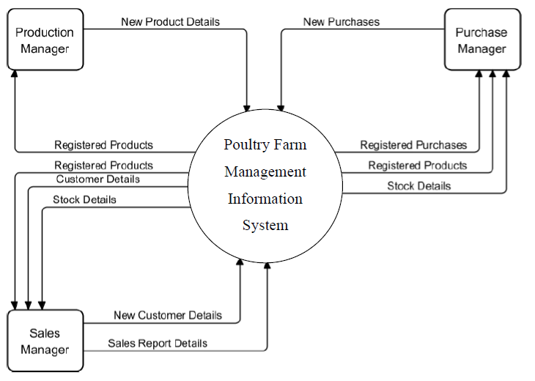

Figure 3 Sequence Diagram of the Poultry Farm Management Information System

### **5.5.3. Level 1 Data Flow Diagram**



Figure 4 Level 1 Data Flow Diagram of the Poultry Farm Management Information System

### **5.5.4. Data Dictionary of Level 1 DFD of Echo-Chick Poultry Farm information management system**

Below are the descriptions of all the design objects used in the system development of Echo-Chick Poultry Information Management System. These objects include processes, Data stores, and the External Entities involved in the system.

Table 1 Description of Process

|  |  |
| --- | --- |
| Process | Description |
| User Registration | Allows the Product Manager, Sales Manager and Purchase Manger to insert their details into the system |
| Authentication | Allows the system to authenticate registered users and provide authentication response. |
| Add Product | Allows the Product manager and the purchase manager to register and view products in the system respectively. |
| Customer Order | It Processes customer orders and allows the sales manager to allocate a product to a customer. |
| View Sales report | Generates a sales reports on products sold to customers. |
| View Suppliers Report | Generates a supplier report. |
| Add Purchases | Allows the purchase manager to add purchases and also view registered purchases. |
| View Purchase Report | Generates a purchase report. |

Table 2 Description of Data Stores

|  |  |
| --- | --- |
| Data Stores | Description |
| Registered User | Stores details of registered users in the system |
| Registered Products | Stores details of registered products |
| Registered customer | Stores details of registered customers. |
| Sales records | Stores registered sales records of the products |
| Purchase Records | Stores registered Purchases. |

Table 3 Description of External Entities

|  |  |
| --- | --- |
| External Entity | Description |
| Sales Manager | The Sales manager is responsible for entering and updating Sales details, views product report, and sales report. |
| Product Manager | The Product manager is responsible for registration of products and viewing registered product report from the system. |
| Purchase Manager | The Purchase Manager is responsible for registration of all purchases made, recording supplier details and viewing stock report, supplier report and purchases report |
| Customer | Browses products, Searches for products, adds items to shopping carts, Views and edits shopping carts, proceeds to checkout, enters shipping and billing information, selects a payment method, submits orders, Tracks orders, manages accounts, Receives order confirmations and shipping notifications and Contacts customer service |

## **5.6 Database Design**

The database design of the system was done by ascertaining the data requirements, entities and their related attributes that make up the system. Modeling of the relationships between the entities was designed with an enriched entity relationship diagram for the system.

### **5.6.1. Data Requirements**

1. Customer. This stores information about customer. The information stored includes CustomerId, role, FirstName, LastName, Telephone, Email, Photo, gender, Password, dob, Address, Security questions, answers and CustomerRegdate.
2. Product. This stores information about products. The information stored includes product ID, CategoryName, ProductName, Product Image, ProductPrice, posting date, Updation and featured.
3. Category. This stores information about products categories. The information stored include id, CategoryName, CategoryCode, PostingDate and Posting Date
4. Orders. This stores information about purchases and orders made. The information stored includes the id, productid, quantity, InvoiceNumber, CustomerName, CustomerContactNo, PaymentMode, InvoiceGenDate and CustomerId.

### **5.6.2. Identification of Entities and Associated Attributes**

Table 4 Entities and the associated Attributes

|  |  |
| --- | --- |
| Entities | Attributes |
| Customer | CustomerId (pk) |
|  | FirstName |
|  | LastName |
|  | role |
|  | Gender |
|  | CustomerContactNo |
|  | Address |
|  | Email |
|  | Password |
|  | Photo |
|  | DOB |
|  | Recovery_Question1 |
|  | Recovery_answer1 |
|  | Recovery_Question2 |
|  | Recovery_answer2 |
| Category | CategoryId (PK) |
|  | CategoryName |
|  | CategoryCode |
|  | PostingDate |
| Product | ProductID (PK) |
|  | CategoryName |
|  | ProductName |
|  | ProductPrice |
|  | PostingDate |
|  | Updation |
| Order | OrderID (PK) |
|  | ProductID |
|  | Quantity |
|  | InvoiceNumber |
|  | CustomerName |
|  | CustomerContactNo |
|  | PaymentMode |
|  | InvoiceGenDate |

### **5.6.3 Modeling of Relationships between Entities.**

Some possible associations between the entities identified were depicted by the relationships model. Among the system's entities, it also provides the corresponding multiplicities (cardinality & participation).

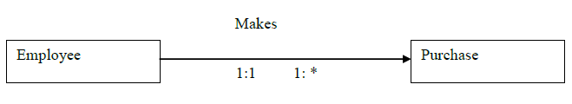

Figure 5 Relationship between the Employee and the purchase

The Employee has one or more purchase and each Purchase instance belongs to a particular Employee. Hence the cardinality is 1: M

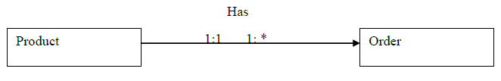

Figure 6 Relationship between the product and the order

A product has one or many Order and each Order instance is for a particular product. Hence the cardinality is 1: M.

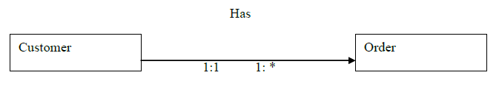

Figure 7 Relationship between the customer and the order

A Customer can make one or more Order and each order instance belongs to a particular customer. Hence the cardinality is 1:M

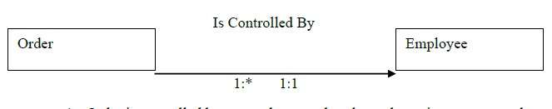

Figure 8 Relationship between the Order and Employee

An Order is controlled by an employee and each employee instance controls one or more orders. Hence the cardinality is M:1

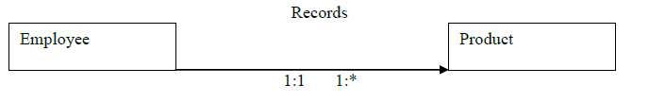

Figure 9 Relationship between the Order and Employee

An Employee records a product and each employee instance controls one or more Products. Hence the cardinality is 1: M.

### **5.6.4 The Entity Relationship Diagram (ERD**

The ERD presented below depicted the entities, some of their attributes and the relationships between them as it was presented individually above. The diagram further indicates the multiplicities between these entities. Therefore, we decided to include the attributes in the ERD in order to avoid presenting and outrageous diagram.

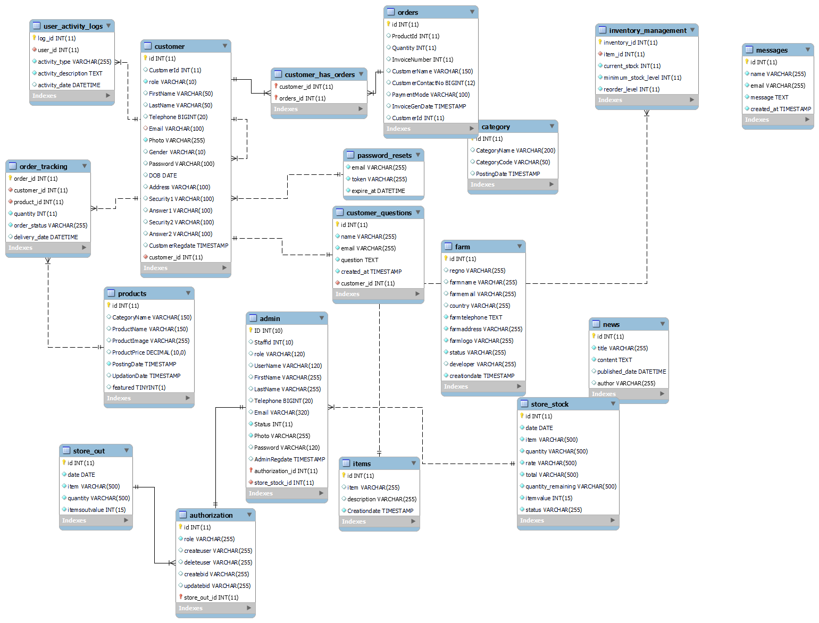

Figure 10 Entity Relationship Diagram (ERD) of Poultry Farm Management Information System

### **5.6.5. Data dictionary**

Table 5 Category Table Structure

|  |  |  |
| --- | --- | --- |
| Field name | Data type | constraint |
| CategoryId | Int (11) | Not null, auto increment, primary key |
| CategoryName | varchar (50) | Not null |
| CategoryCode | varchar (20) | Not null |
| PostingDate | date | Not null |

Table 6 Customer Table Structure

|  |  |  |
| --- | --- | --- |
| Field name | Data type | constraint |
| CustomerId | Int (11) | Not null, auto increment, primary key |
| FirstName | varchar (50) | Not null |
| LastName | varchar (50) | Not null |
| Gender | varchar (10) | Not null |
| CustomerContactNo | varchar (15) | Not null, index key |
| Address | varchar (100) | Not null |
| Email | varchar (100) | Not null |
| Password | varchar (100) | Not null |
| DOB | date | Not null |
| Recovery_Question1 | varchar (100) | Not null |
| Recovery_answer1 | varchar (100) | Not null |
| Recovery_Question2 | varchar (100) | Not null |
| Recovery_answer2 | varchar (100) | Not null |

Table 7 Order Table Structure

|  |  |  |
| --- | --- | --- |
| Field name | Data type | constraint |
| OrderID | int (11) | Not null, auto increment, primary key |
| ProductID | int (11) | Not null, Foreign key |
| Quantity | int (11) | Not null |
| InvoiceNumber | varchar (50) | Not null |
| CustomerName | varchar (50) | Not null |
| CustomerContactNo | varchar (15) | Not null, Foreign key |
| PaymentMode | varchar (50) | Not null |
| InvoiceGenDate | date | Not null |

Table 8 Product Table Structure

|  |  |  |
| --- | --- | --- |
| Field name | Data type | constraint |
| ProductID | int (11) | Not null, auto increment, primary key |
| CategoryName | varchar (50) | Not null |
| ProductName | varchar (100) | Not null |
| ProductPrice | decimal (10,2) | Not null |
| PostingDate | date | Not null |
| Updation | timestamp | Not null |

## **5.8 Chapter Summary**

This chapter has outlined the comprehensive system design of the proposed Poultry Farm Management System (PFMS). The system design encompasses a detailed description of the proposed system, a thorough requirements analysis, a three-tier conceptual architecture, process logic design using various diagrams, a normalized database design, and user-friendly I/O design. The PFMS is designed to provide poultry farmers with a comprehensive and efficient tool for managing their operations, enhancing productivity, and improving profitability.

# **CHAPTER SIX: IMPLEMENTATION SYSTEM & TESTING**

## **6.1 Chapter Introduction**

This chapter delves into the practical application of the developed system, elucidating its implementation process, rigorous testing methodologies employed, and comprehensive evaluation criteria adopted to ascertain its efficiency and reliability.

## **6.2 System screenshots**

This section provides a visual representation of key interfaces within the system to showcase its functionality and user-friendly design.

### **6.2.1. System login page**

This shows the first page of the system. All the users have access to the system through this page. The users of the system have to be authenticated first by entering their required Email and passwords before they can be able to access the system.

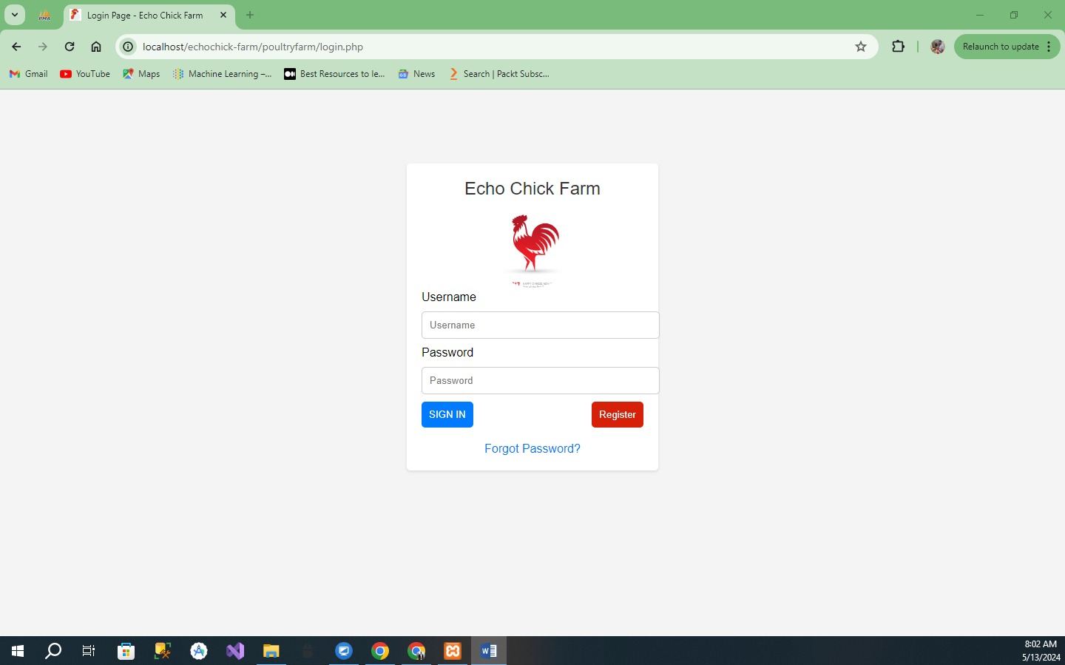

Figure 11 System Login

### **6.2.2. Authentication**

Authentication allows the system to authenticates registered users and provide authentication response when wrong login details are used to have access to the system.

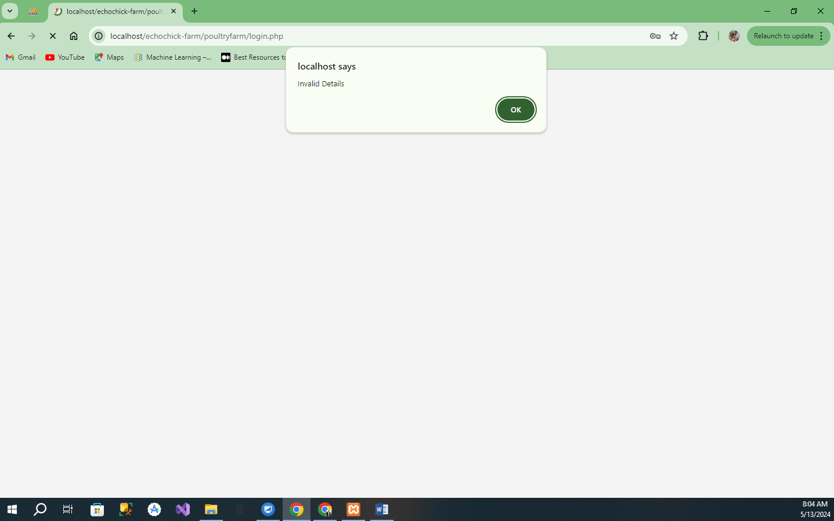

Figure 12 Authentication Response

### **6.2.3 User Registration**

The User Registration allows new users of the system to register, a unique password which is encrypted on submission to the system database.

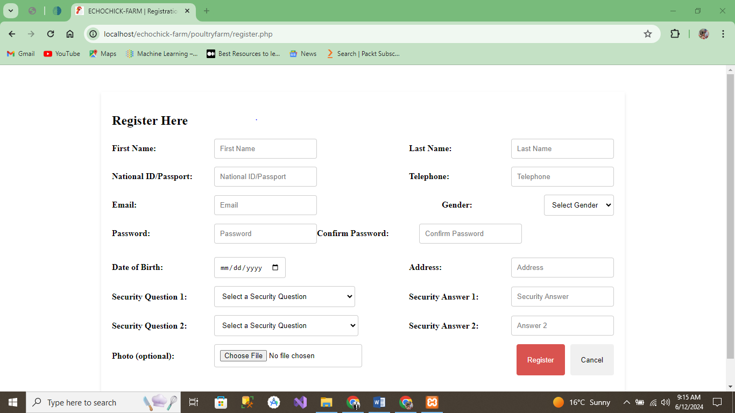

Figure 13 User Registration Form

### **6.2.4 Invoice Report**

View Invoice report process allow the administrator to view complete report of the available employees in the system.

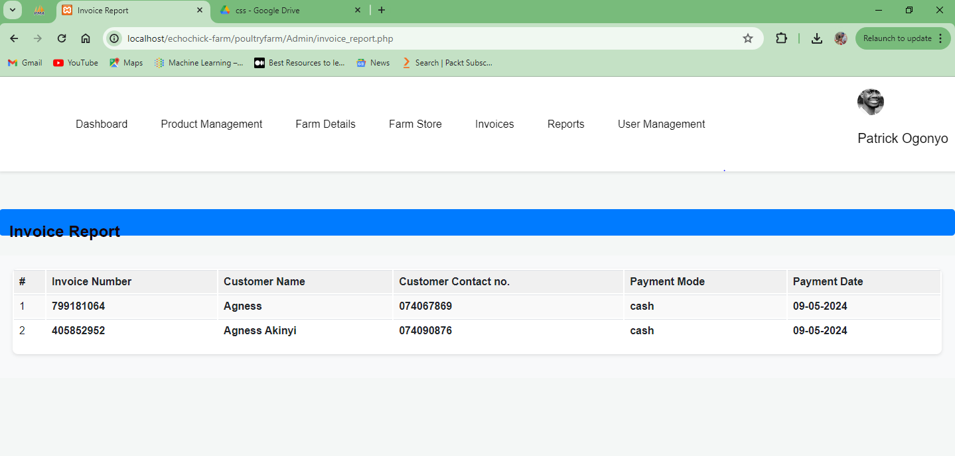

Figure 14 Invoice report

## **6.3 Testing plan**

The poultry farm management information system was tested using unit, integration and system testing techniques. After every part of the system was implemented, it was tested using input to guarantee that each unit responded as expected. After individual units were tested as they were being developed, those whose functionality was association to others were integrated and also tested using integrated testing. With this, interaction between these units was verified and defects also corrected.

System testing was performed on the complete integrated system to check whether all the specified requirements were met. These three types of testing were done by the project team developers. User acceptance system was done by the users of the system. A sample of six users of the system each was used to test the system functionality.

In general, the users stated that the system had a clean layout, was simple and easy to learn. In other words, it was user friendly. They also commented that it will easy information management within the different poultry farms of the company. Below are some of the tested cases that we are used to test the system:

Table 7 Login Test Case

|  |  |  |  |
| --- | --- | --- | --- |
| **Description** | **User’s action** | **Expected System Response** | **Observed System Response** |
| 1. Login with right password | User with the right credentials | System to take user the appropriate page based on the user’s roles. | System responded as expected |
| 2. Login with wrong password | User input wrong credentials | System to prompt the user to enter correct  credentials again. | System responded as expected. |

Table 8 User Registration Test Case

|  |  |  |  |
| --- | --- | --- | --- |
| Description | Admins Action | Expected System Response | Observed System Response |
| 1. Registering a User | customer enters details | System to registered the customer based on his roles. | System responded as expected. |
| 2. Registering a user with wrong details or format | Customer input wrong details or format | System to prompt the Customer to enter the right detail again. | System responded as expected. |

## **6.4 Evaluation plan**

The evaluation criteria for the poultry information management system cover essential aspects to ensure its efficacy, reliability, and adherence to specifications. These include performance evaluation (system speed, responsiveness, resource utilization), usability (interface intuitiveness, navigation), data integrity (consistency, validation, accuracy), security (authentication, data encryption, audit trails), scalability and reliability (the system's capacity to handle increased loads), and compliance (adherence to standards and regulations). We also gather end-user satisfaction and feedback to guide future enhancements.

## **6.5 Chapter summary**

We meticulously implemented and rigorously tested the Poultry Information Management System (PIMS) to ensure its effectiveness, reliability, and adherence to established standards. The comprehensive evaluation plan ensured the system's readiness for deployment, with positive feedback from user acceptance testing further validating its potential to streamline information management and enhance operational efficiency within the poultry industry. This chapter effectively demonstrates the successful implementation and validation of PIMS, paving the way for its adoption and utilization.

# **CHAPTER SEVEN: CONCLUSIONS, FINDINGS & RECOMMENDATIONS**

## **7.1 Introduction**

This final chapter summarizes the outcomes of the Poultry Information Management System (PIMS) project, highlighting the key conclusions drawn from the development, implementation, and testing phases. It also discusses the challenges encountered during the project and provides recommendations for future enhancements to the system.

## **7.2 Conclusion**

The Poultry Information Management System's development and deployment have successfully met the initial objectives and requirements. The system demonstrated robust functionality, ease of use, and reliability through rigorous testing phases, which included unit, integration, and system tests, followed by user acceptance testing. The positive feedback from end-users and the alignment of system performance with project goals confirm the effectiveness of PIMS in improving information management and operational efficiency within the poultry industry.

## **7.3 Challenges Encountered**

Several challenges were encountered during the project, including:

1. Technical Difficulties: Integration of different system modules occasionally led to technical glitches that required extensive debugging and adjustments.
2. User Adaptation: Some users initially struggled with adapting to the new system, indicating a need for more comprehensive training sessions.
3. Data Migration: The transfer of existing data into the new system was more complex and time-consuming than anticipated, highlighting the need for a more streamlined data migration strategy.

## **7.4 Future Recommendations**

To enhance the functionality and user experience of the PIMS, the following recommendations are proposed:

1. Continuous Training: Implement ongoing training programs to help users become more proficient with the system, thereby maximizing its utility.
2. System Upgrades: Regularly update the software to incorporate new technologies and features that enhance system performance and security.
3. Enhanced Data Migration Tools: Develop more efficient tools for data migration to minimize downtime and ensure data integrity during the transition to upgraded systems.
4. User Feedback Integration: Establish a structured mechanism for collecting and integrating user feedback into system development to ensure that the system evolves in line with user needs and industry trends.

## **7.5 Conclusion**

In conclusion, the Poultry Information Management System has proven to be a valuable asset for the poultry industry, significantly enhancing the management of information and operational processes. While there were challenges, the solutions implemented have led to a robust and effective system. The recommendations provided aim to further improve and adapt the system to future needs, ensuring its relevance and effectiveness in enhancing productivity and decision-making within the industry.

# **References**

Alles, M., & Gray, G. L. (2020). “The first mile problem”: Deriving an endogenous demand for auditing in blockchain-based business processes. *International journal of accounting information systems*, *38*, 100465.

Astill, J., Dara, R. A., Fraser, E. D., Roberts, B., & Sharif, S. (2020). Smart poultry management: Smart sensors, big data, and the internet of things. *Computers and Electronics in Agriculture*, *170*, 105291.

Chai, K. H., Azizi, M. M. F., Romeli, S., Lau, H. Y., & Lau, H. Y. (2023). Deployment of IoT Sensors in the Revolution of Agriculture.

Debauche, O., Trani, J. P., Mahmoudi, S., Manneback, P., Bindelle, J., Mahmoudi, S. A., ... & Lebeau, F. (2021). Data management and internet of things: A methodological review in smart farming. Internet of Things, 14, 100378.

ElDahshan, K., Selim, E., Ebada, A. I., Abouhawwash, M., Nam, Y., & Behery, G. (2022). Handling Big Data in Relational Database Management Systems. *CMC-COMPUTERS MATERIALS & CONTINUA*, *72*(3), 5149-5164.

Emal, J., & Muhsni, A. M. (2017). Backyard Poultry Production System in Afghanistan. *Backyard Poultry Production Systems in SAARC Member States*, *1*.

Gonta Gobena, E., & Urge, P. (2021). *ASSESSMENT OF SMALLHOLDER CHICKEN PRODUCTION PRACTICES AND EVALUATION OF LOCAL FEED RESOURCES IN TWO DISTRICTS OF SOUTH OMO ZONE, ETHIOPIA* (Doctoral dissertation, Haramaya university).

Gordon, I. (Ed.). (2017). Reproductive technologies in farm animals.

Jobe, G. J. C. (2020). *Governing Value Chain Disruption in Agriculture and Agri-Food Production: A Behavioural Approach to Assessing Markets for Agricultural Data* (Doctoral dissertation, University of Saskatchewan).

Kebede, E. (2017). Growth performance and rearing costs of Fayoumi and White Leghorn chicken breeds. *East African Journal of Sciences*, *11*(1), 37-42.

Lukefahr, S. D., Cheeke, P. R., McNitt, J. I., & Patton, N. M. (2004). Limitations of intensive meat rabbit production in North America: A review. *Canadian journal of animal science*, *84*(3), 349-360.

Mao, Y., Hopkins, D. L., Zhang, Y., & Luo, X. (2016). Consumption patterns and consumer attitudes to beef and sheep meat in China. *American Journal of Food and Nutrition*, *4*(2), 30-39.

Ng'ang'a, J. M. (2014). *Factors influencing implementation of poultry farming enterprises for economic empowerment of local communities in Mombasa county, Kenya* (Doctoral dissertation, University of Nairobi).

Ojo, R. O., Ajayi, A. O., Owolabi, H. A., Oyedele, L. O., & Akanbi, L. A. (2022). Internet of Things and Machine Learning techniques in poultry health and welfare management: A systematic literature review. *Computers and Electronics in Agriculture*, *200*, 107266.

Ren, G., Lin, T., Ying, Y., Chowdhary, G., & Ting, K. C. (2020). Agricultural robotics research applicable to poultry production: A review. *Computers and Electronics in Agriculture*, *169*, 105216.

Saiz-Rubio, V., & Rovira-Más, F. (2020). From smart farming towards agriculture 5.0: A review on crop data management. *Agronomy*, *10*(2), 207.

Singh, C., Khilari, S. H., & Nair, A. N. (2022). Farming-as-a-service (FAAS) for a sustainable agricultural ecosystem in India: design of an innovative farm management system 4.0. In *Digital Transformation and Internationalization Strategies in Organizations* (pp. 85-123). IGI Global.

Zheng, H., Zhang, T., Fang, C., Zeng, J., & Yang, X. (2021). Design and implementation of poultry farming information management system based on cloud database. *Animals*, *11*(3), 900.

# **Appendix**

## **Sample questionnaires**

Question 5: If the Poultry Management information system is implemented, how would you like it to affect the existing system?

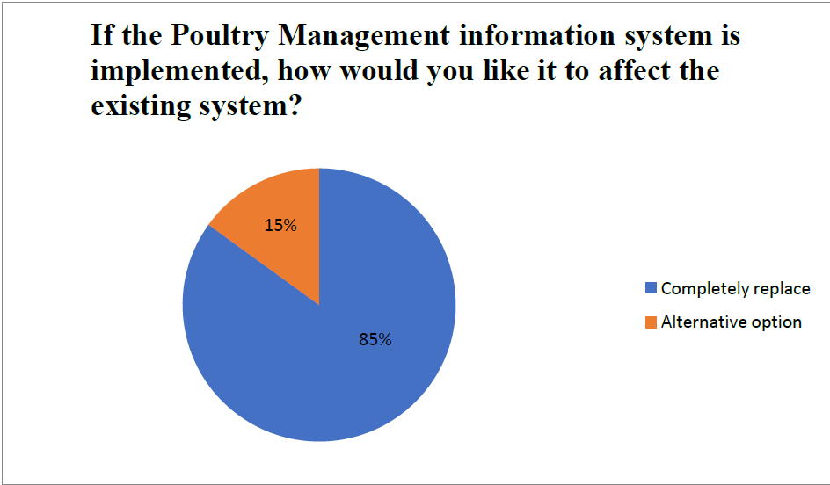

Figure 15 Pie Chart Showing Responses of the Fifth Question of the Questionnaire

## **Sample interviews**

|  |  |  |  |
| --- | --- | --- | --- |
| Question | Manager Answer | Supervisor Answer | Conclusion |
| Is the method of recording and maintaining agricultural records accurate?  Explain your response. | No, since payments for workers paid in wages take time to process because daily activity records must be balanced before payments are made. | No, there is overtime labor involved in analyzing everyday activities and costs incurred. | The current approach is inconvenient since all farm records are kept manually on paper, making it difficult to compile timely farm reports. |

## **Project Budget**

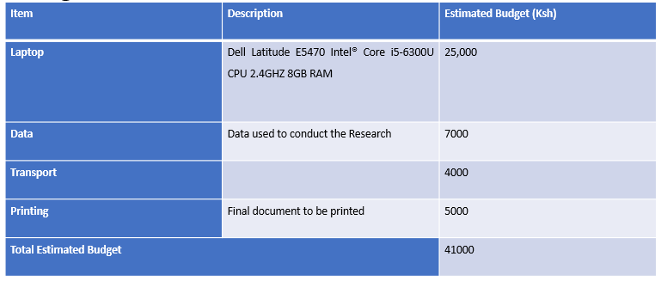

Figure 16 Project Budget

## **Time Schedule**

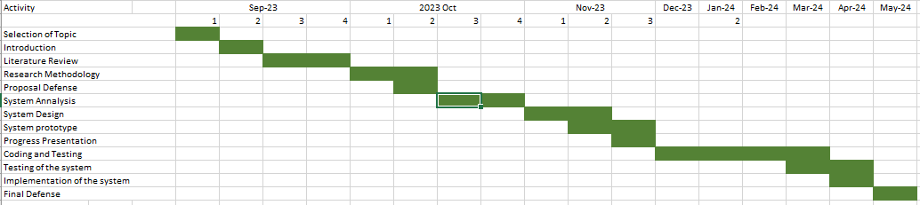

Figure 17 Time Schedule for the Project

**Sample code** 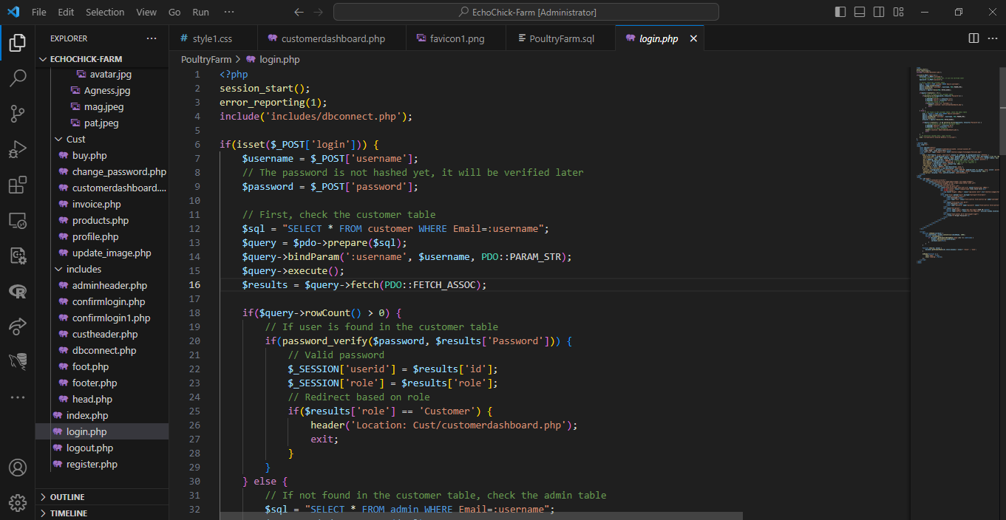

Figure 18 Login.php

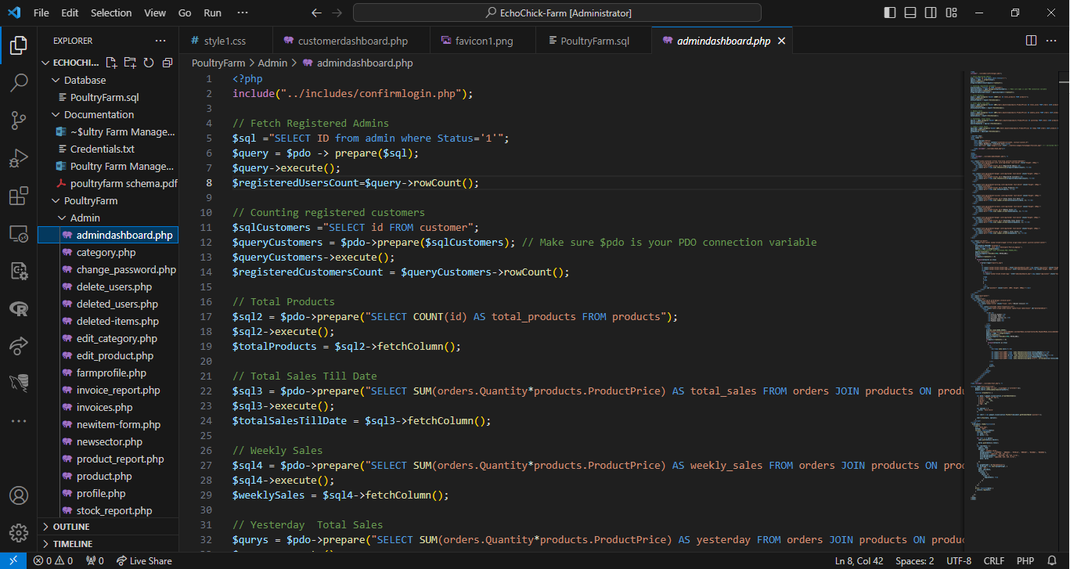

Figure 19 Admindashboard.php